**Output**

1. **Starting of backend Spring Boot Application.**

**SS**

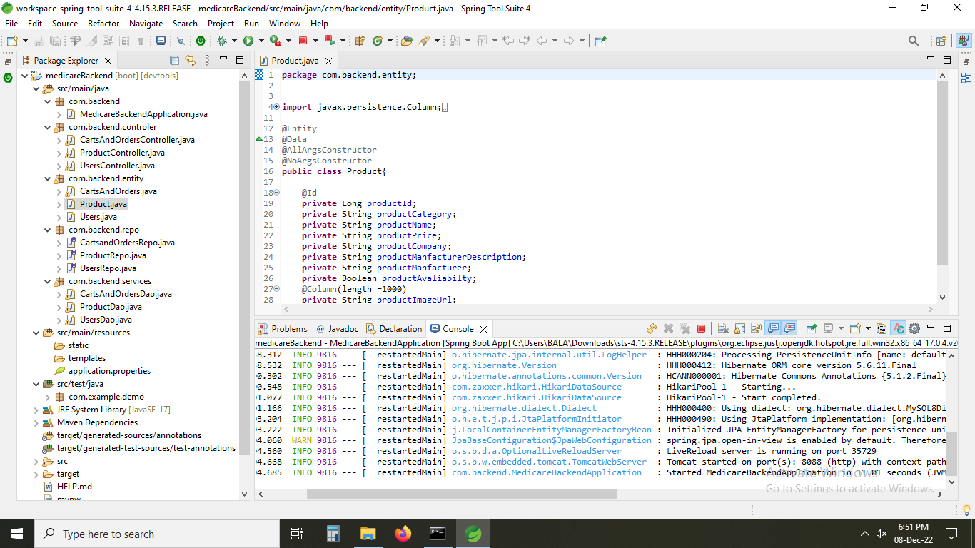

1. **opening of vs code.**

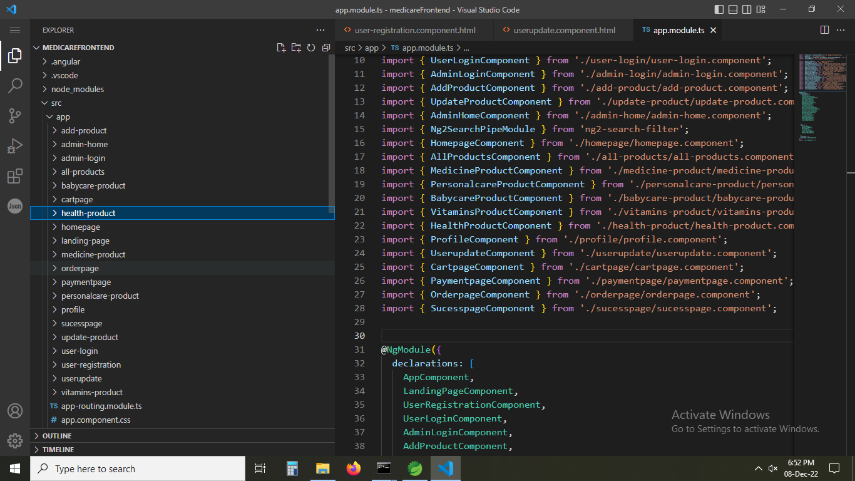

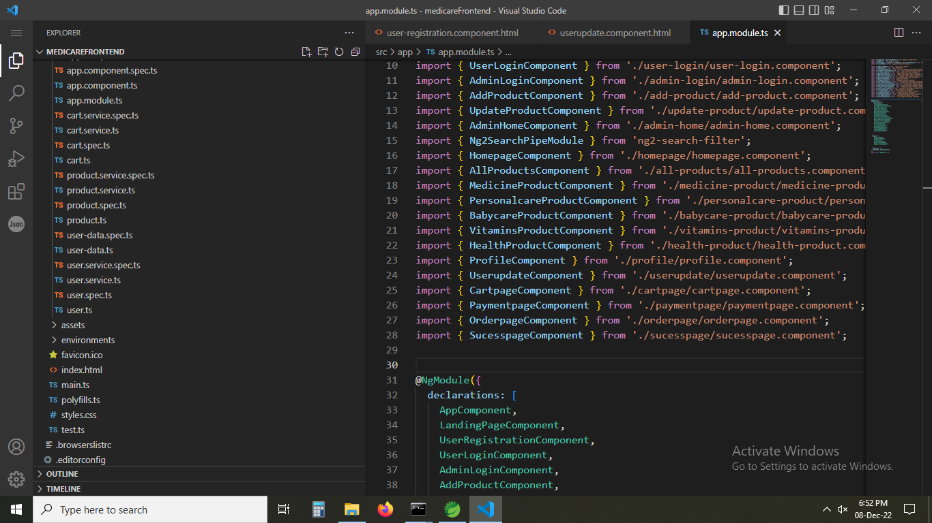

1. **opening the path in cmd and using ng serve code to start angular frontend application.**

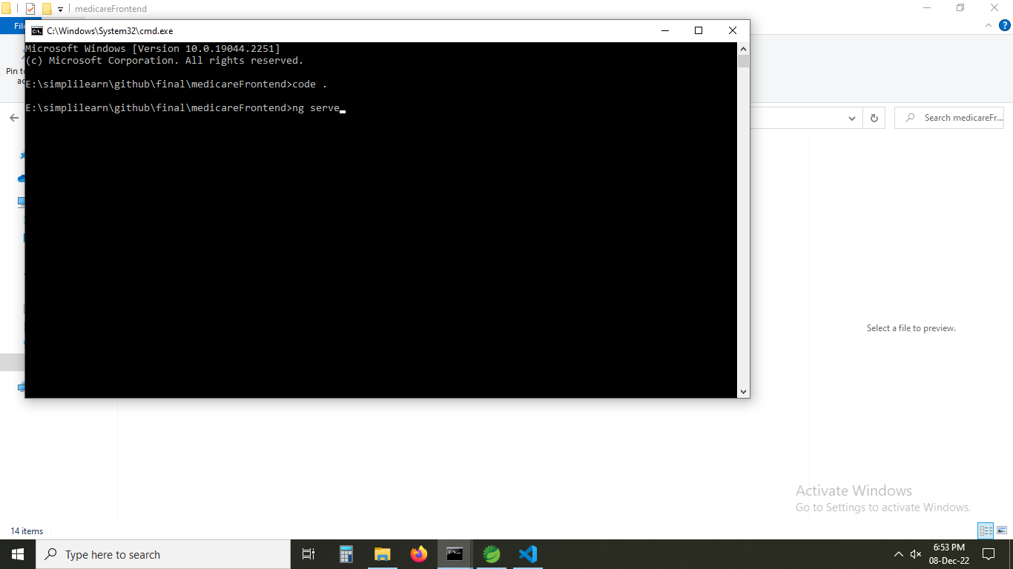

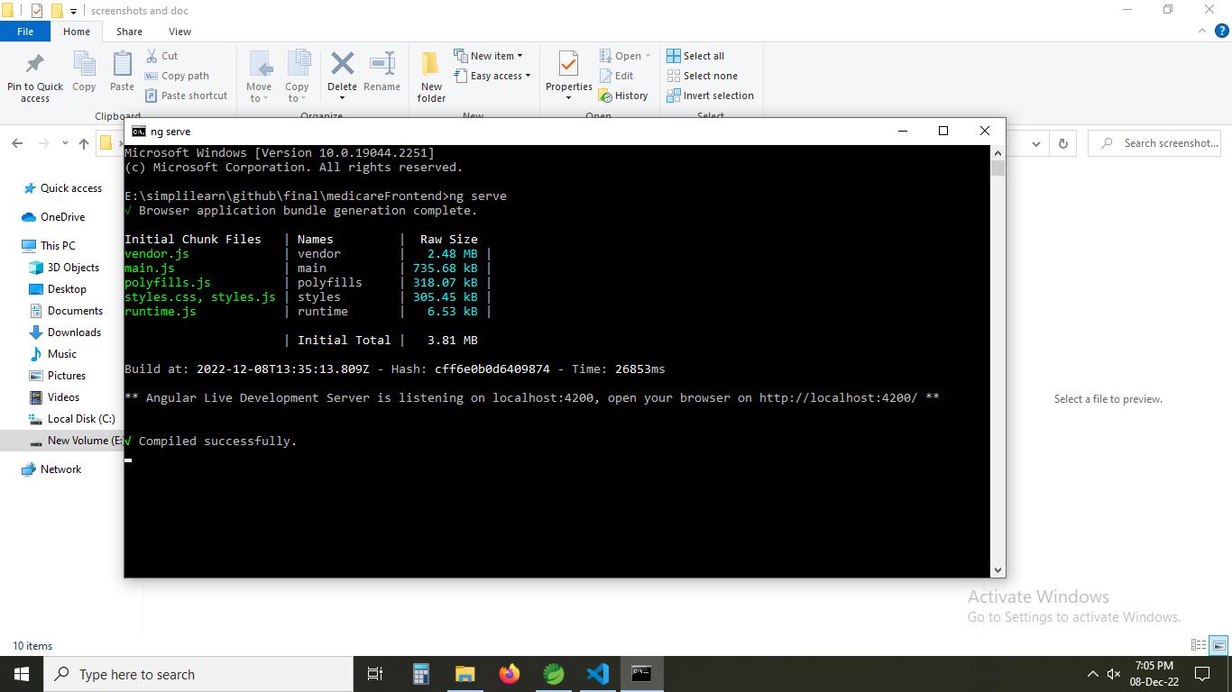

1. **Running localhost:4200/userhome url and Home page is opened.**

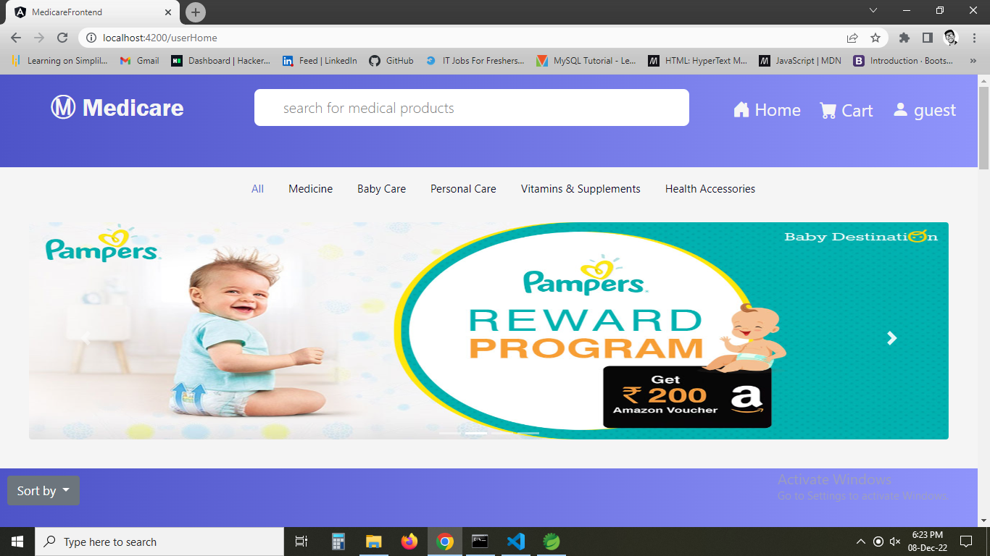

1. **All the products are shown in the website application.**

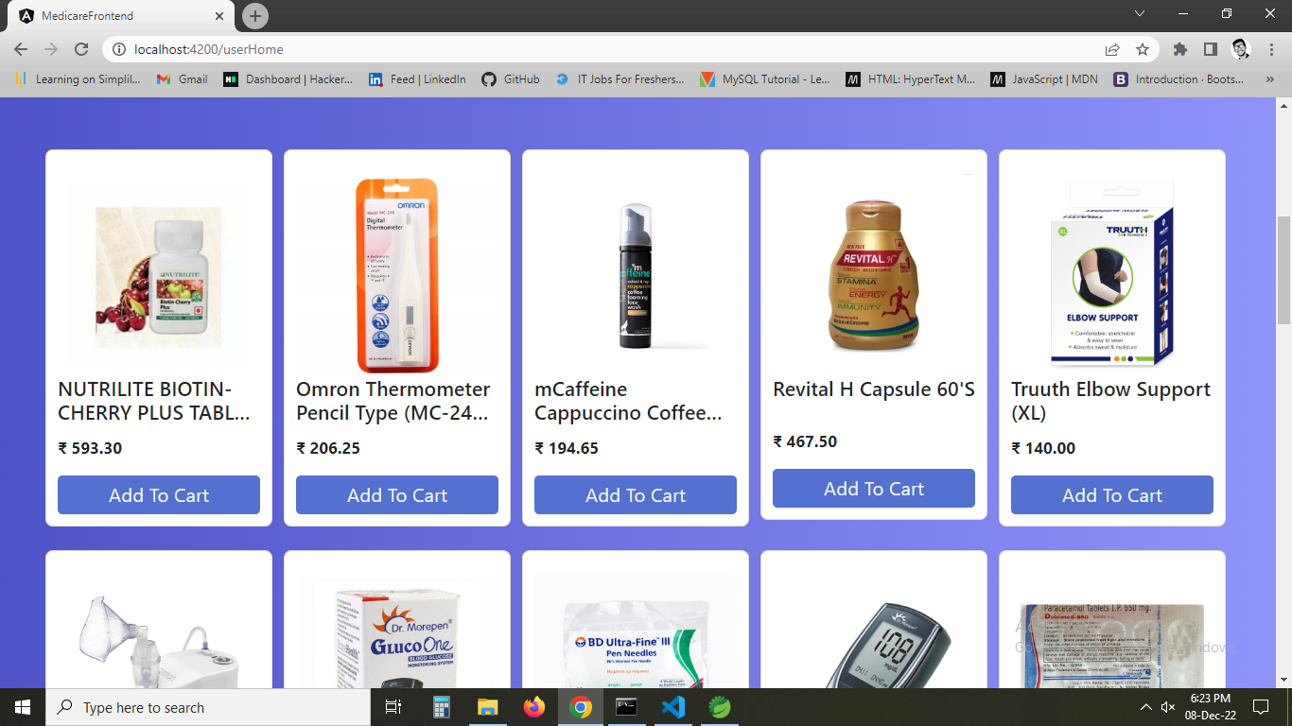

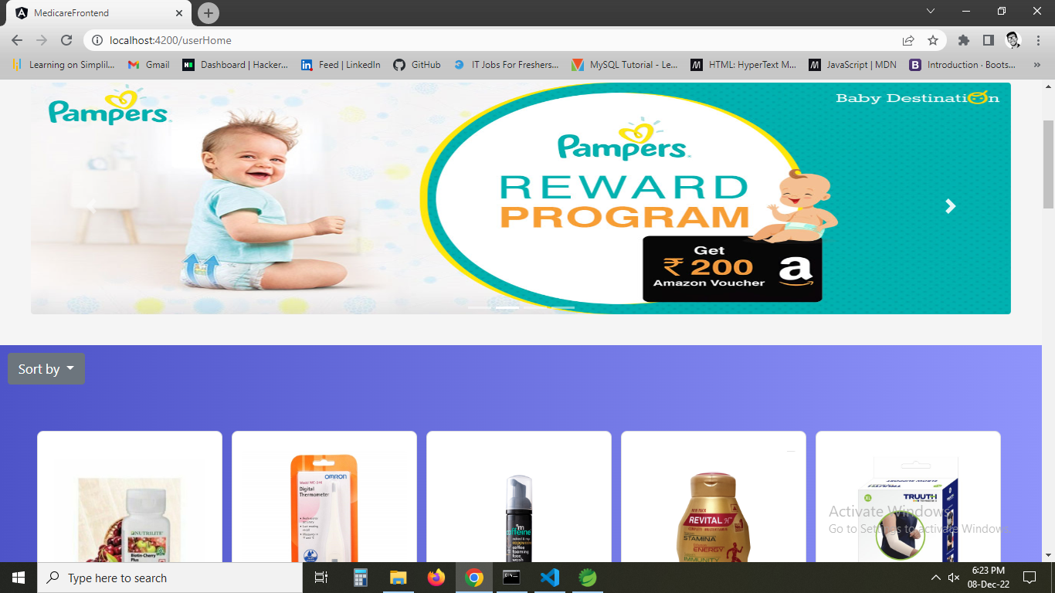

1. **Using Search it is showing product starting with name.**

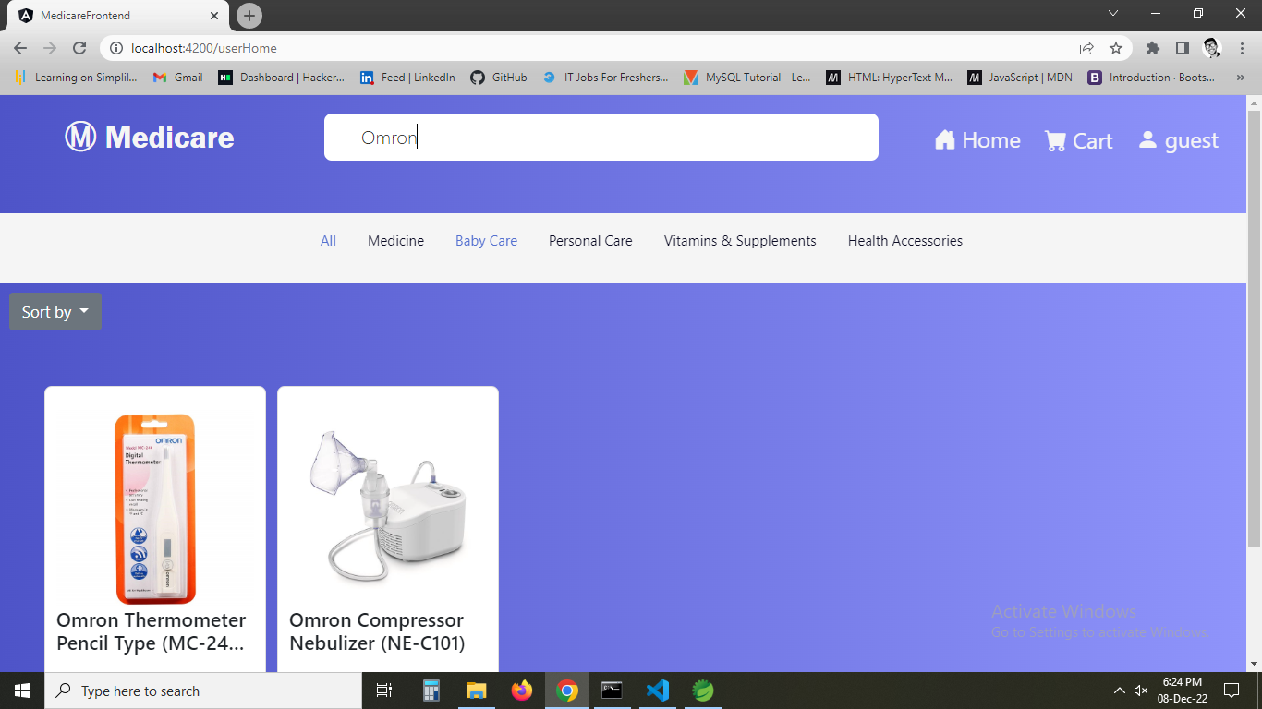

1. **Using nav links as filter product by category.**

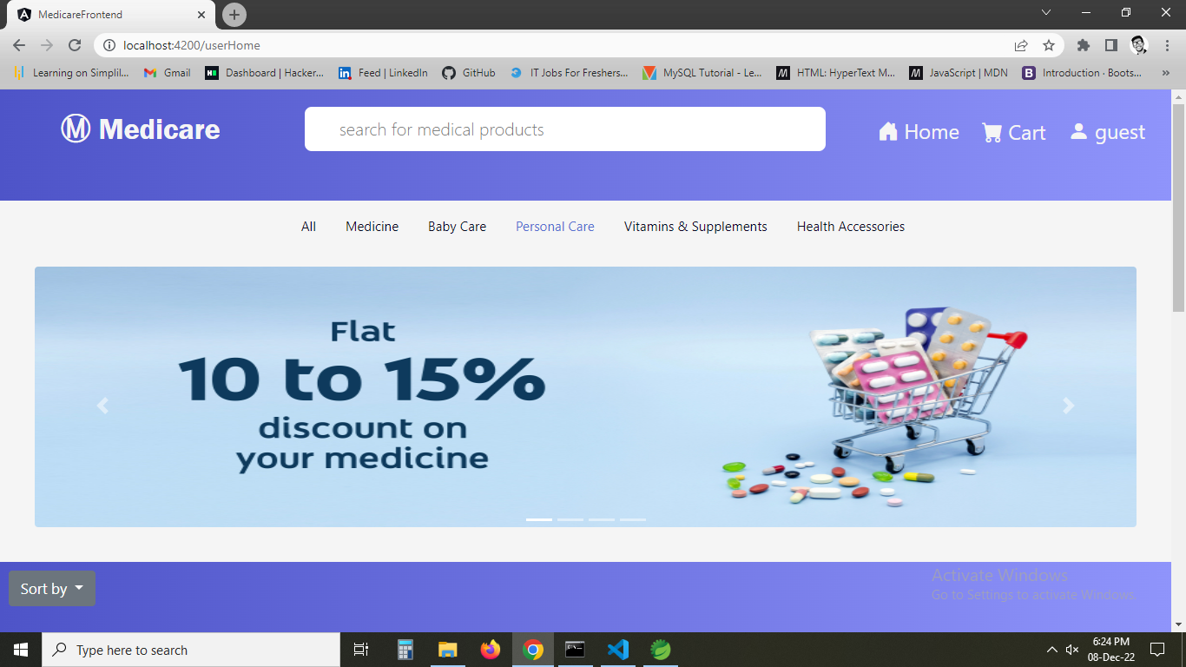

1. **all the products in personal care are shown.**

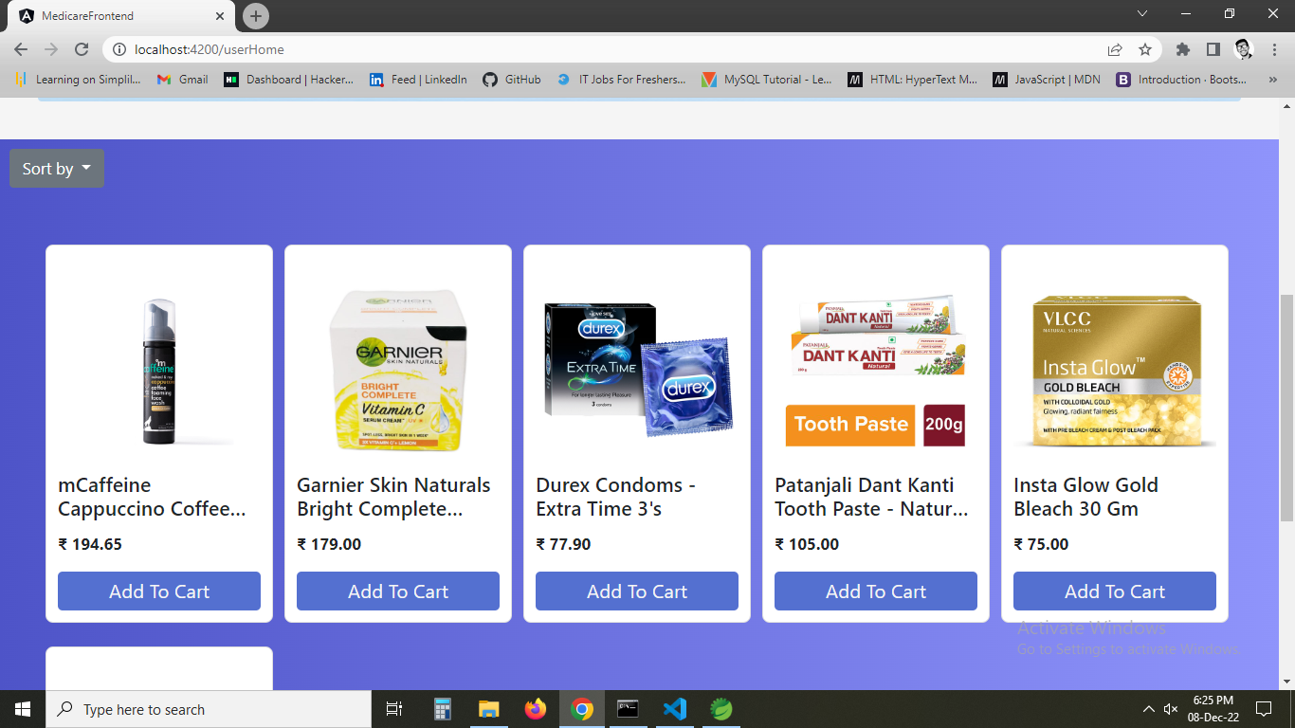

1. **changin category in nav link**

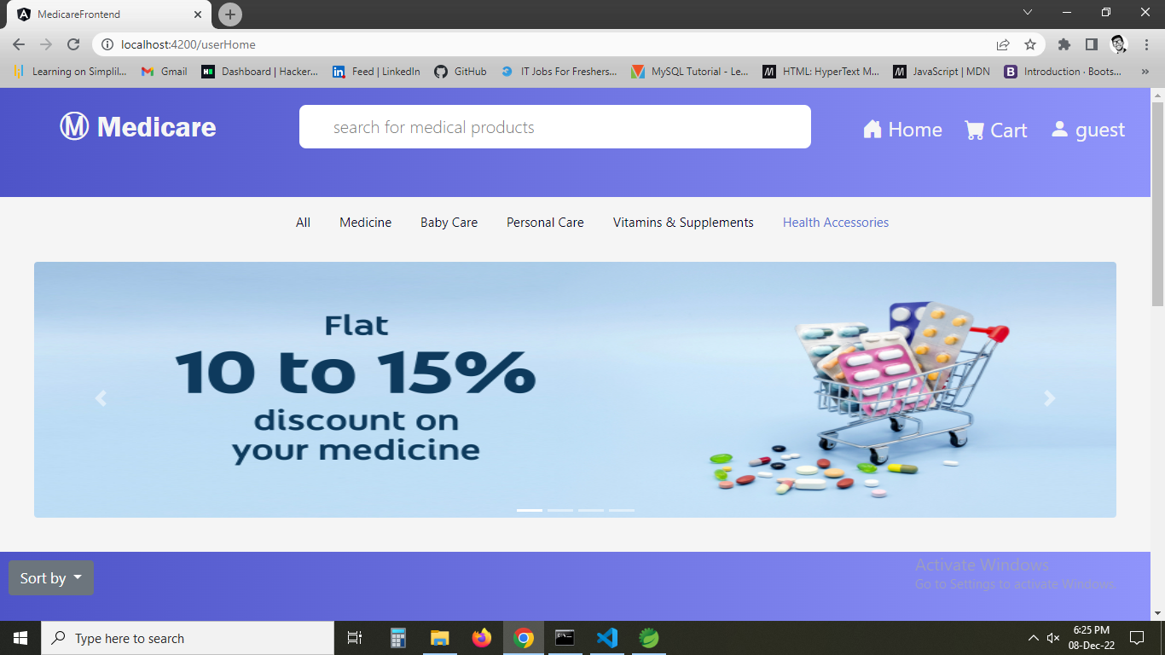

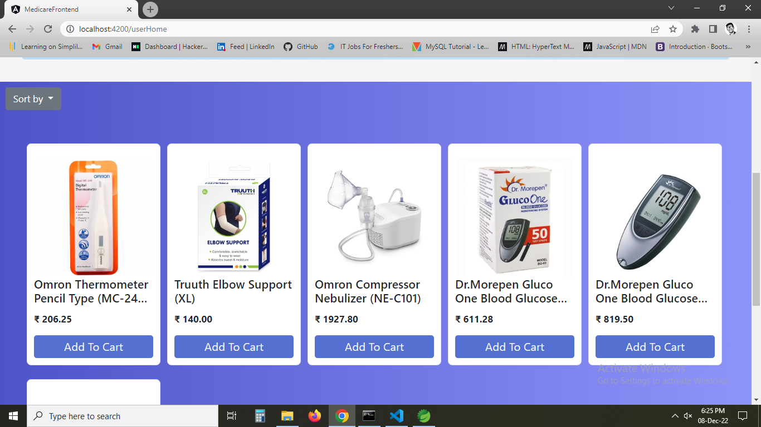

1. **Trying sort by price low to high**

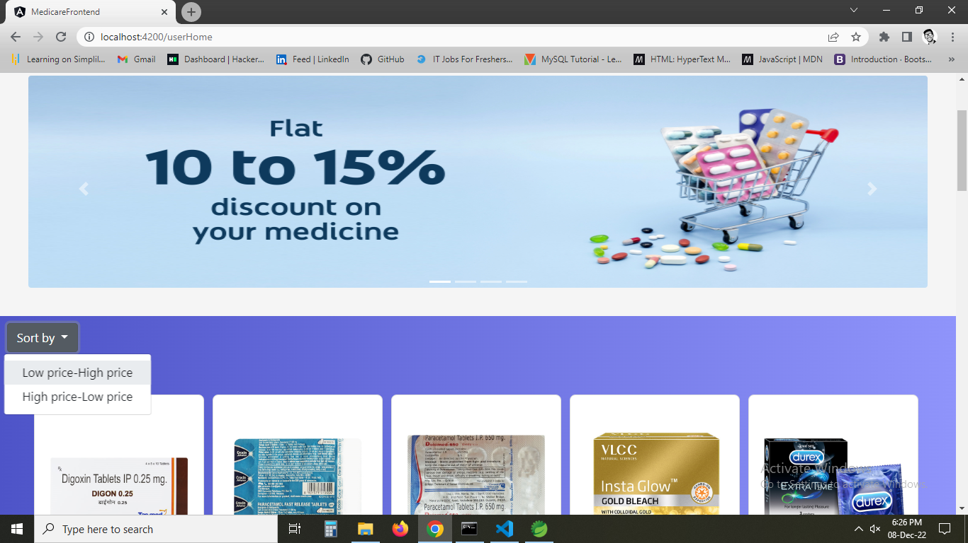

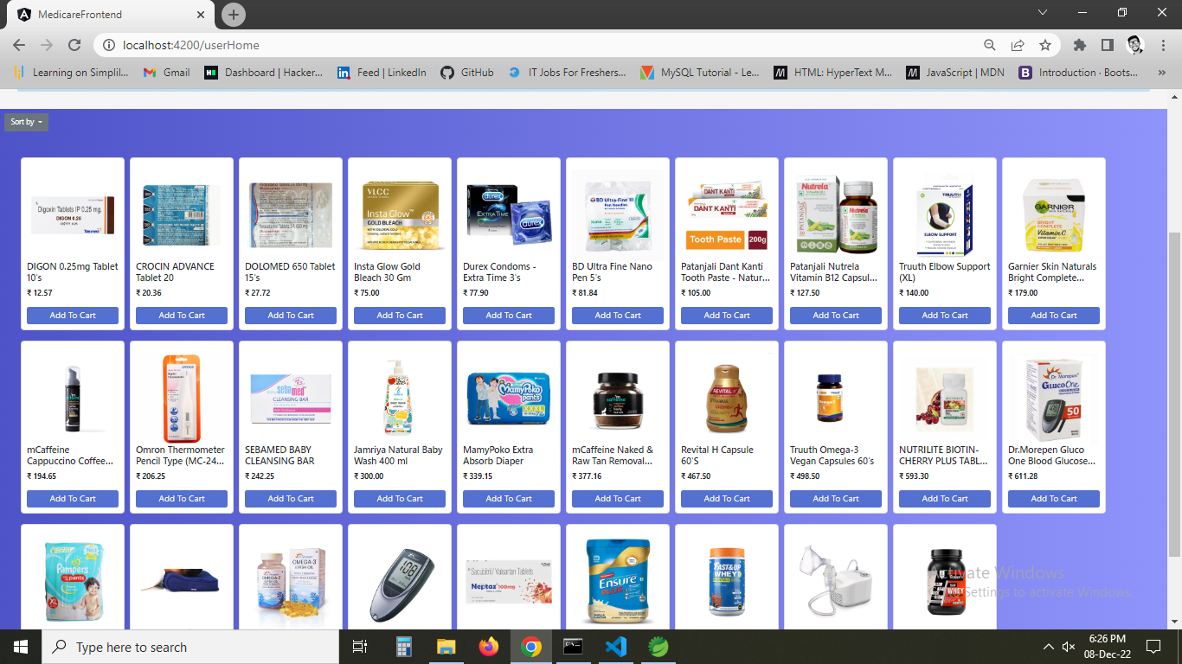

1. **Trying price high to low**

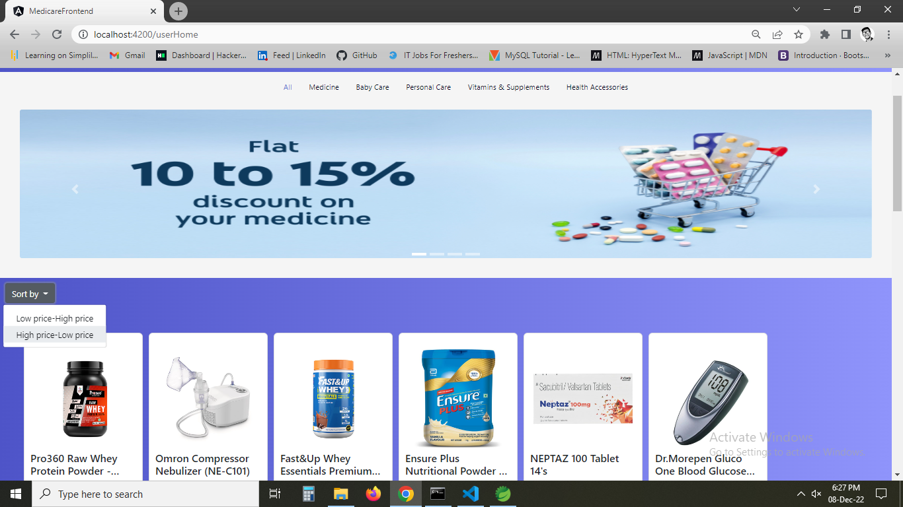

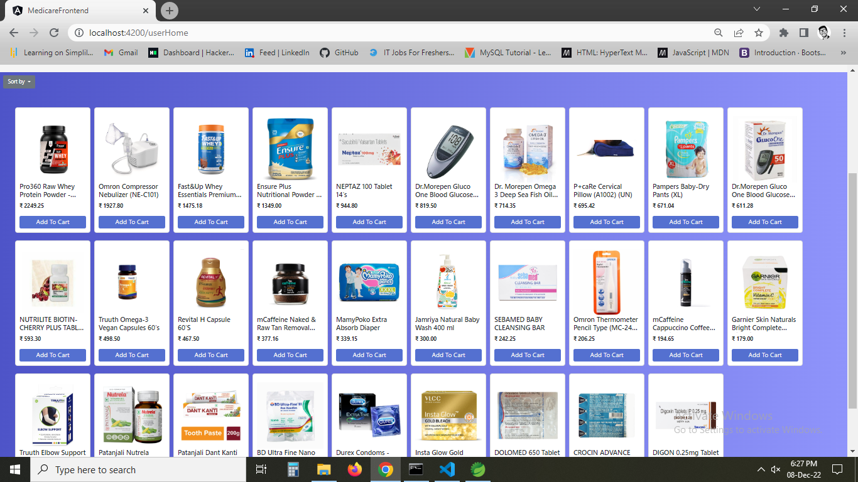

1. **If you click on add to cart or cart button it asks u to login to continue as you are a guest.**

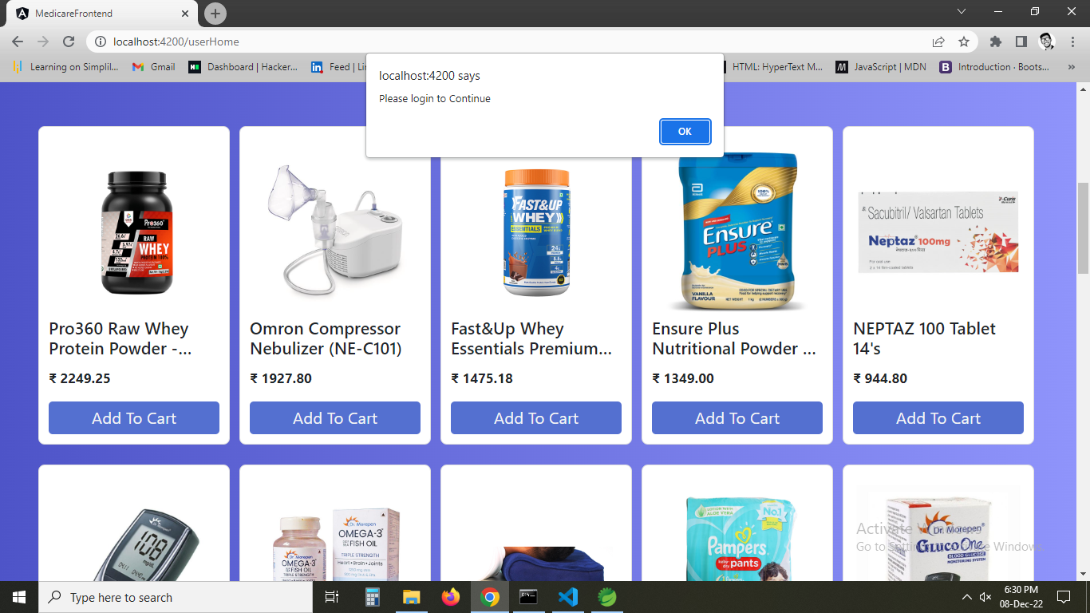

1. **On ok it redirects to a page and now trying admin login.**

**Username:admin**

**Password:admin**

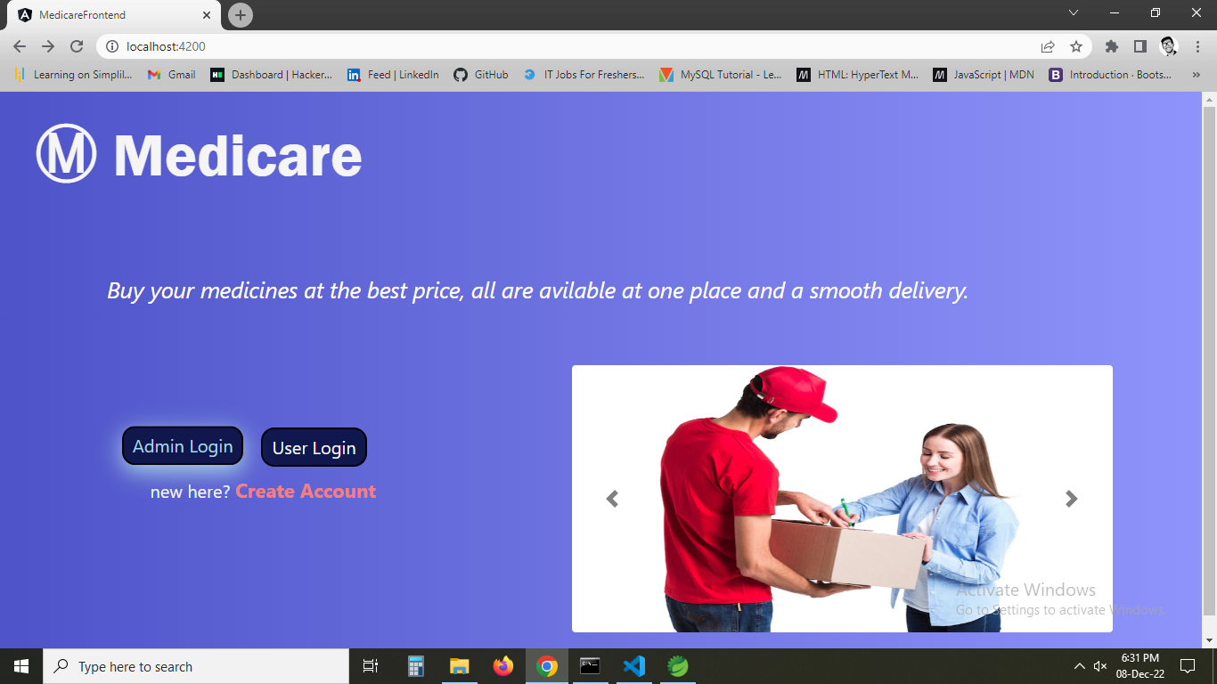

1. **Admin home page is shown where all options are shown**

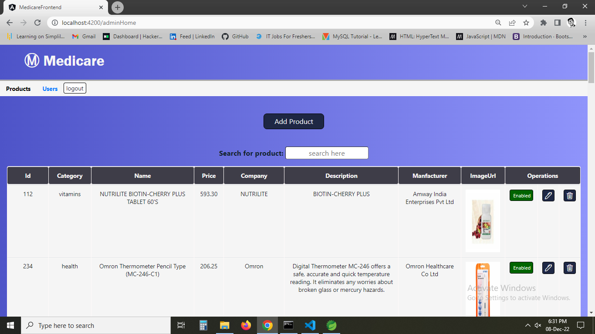

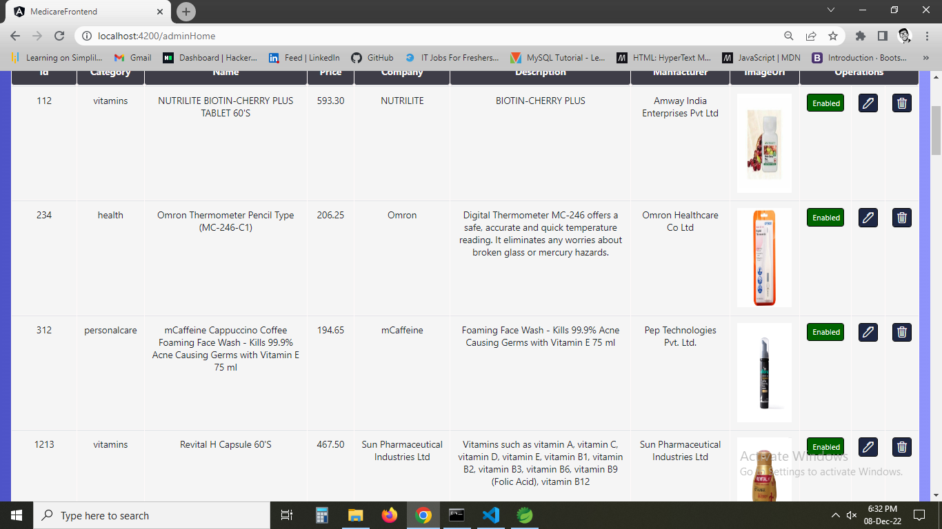

1. **You have enable and disable button to show availability of product or disable the product in case not to show particular product to user.**

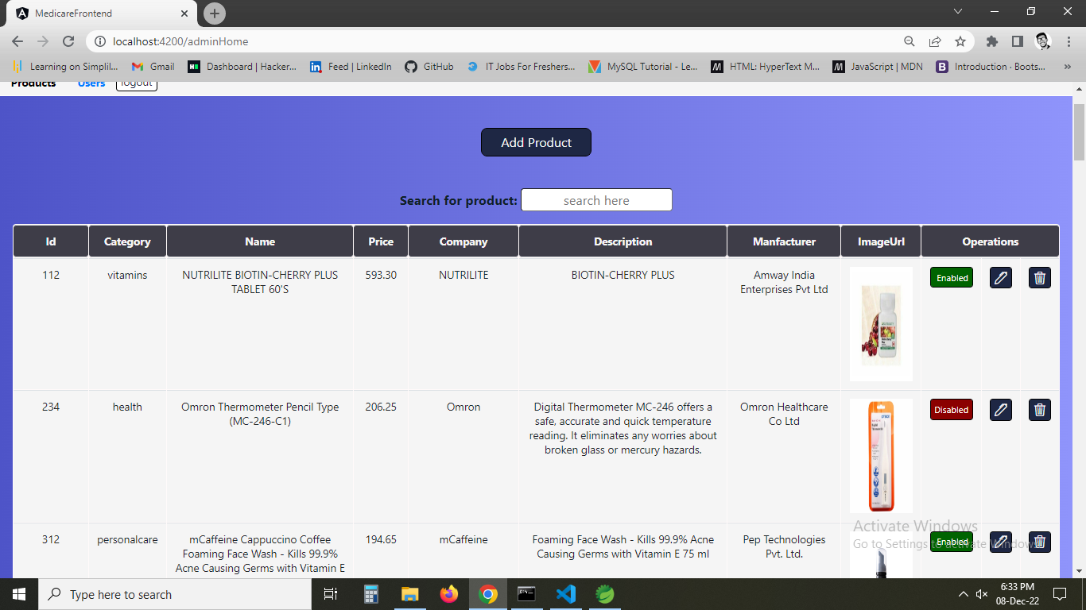

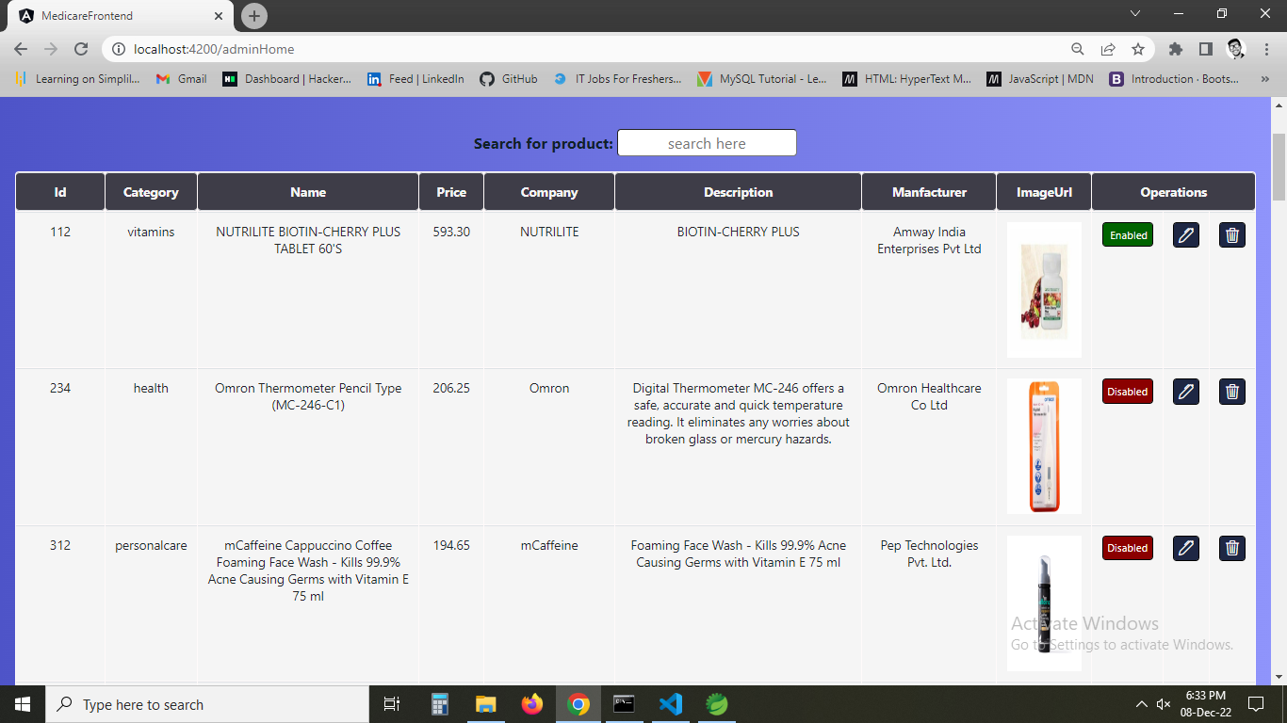

1. **Now trying add product button a form is displayed to show the products.**

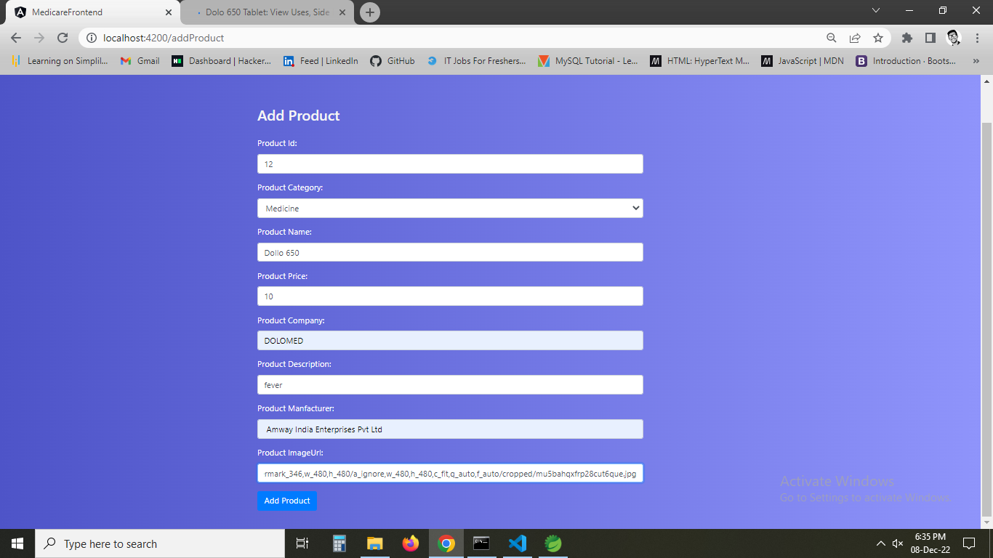

1. **The particular product I entered is shown in the table of data.**

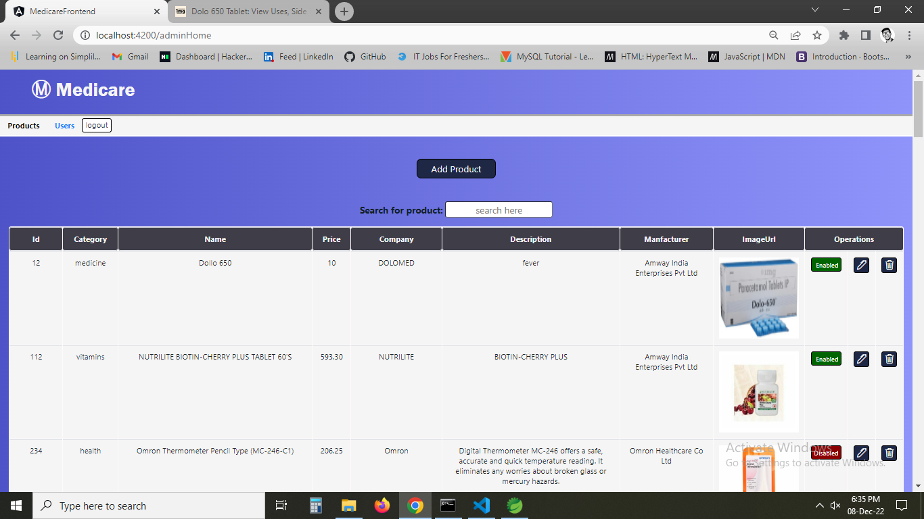

1. **As like that we can edit and if I click delete particular item is displayed.**

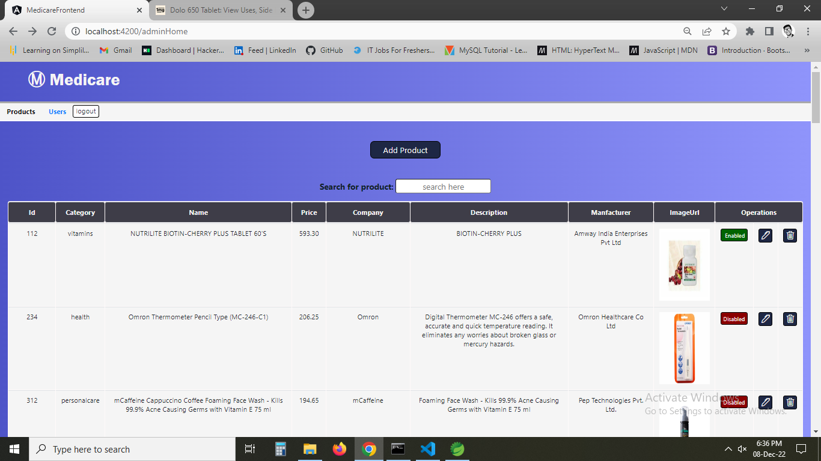

1. **searching particular product with id.**

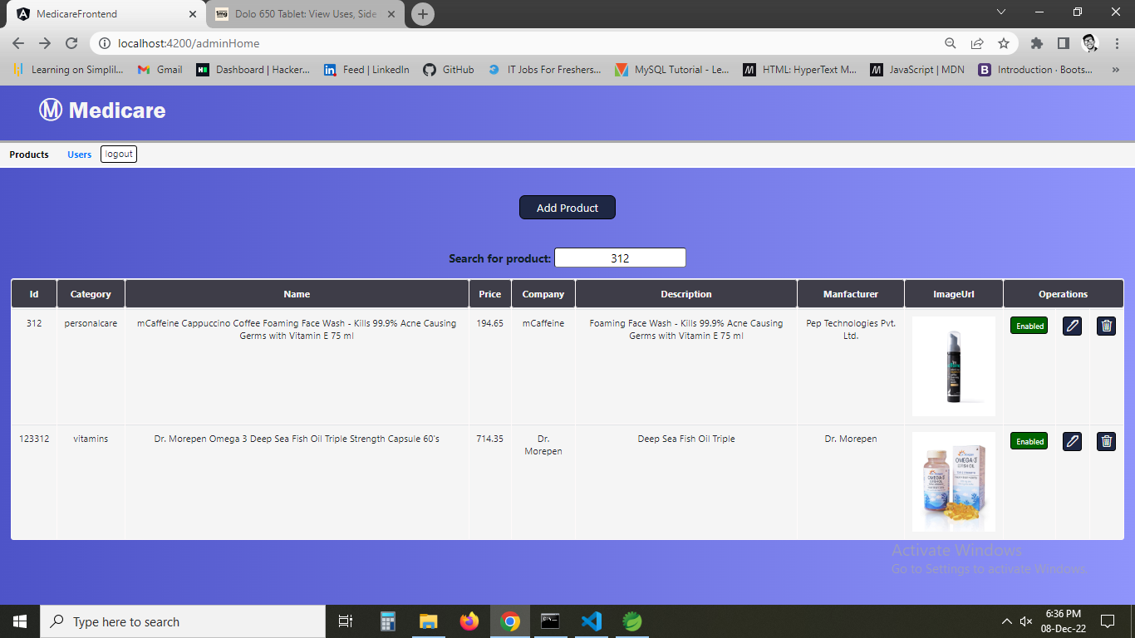

1. **now using user tab all the data of users are shown.**

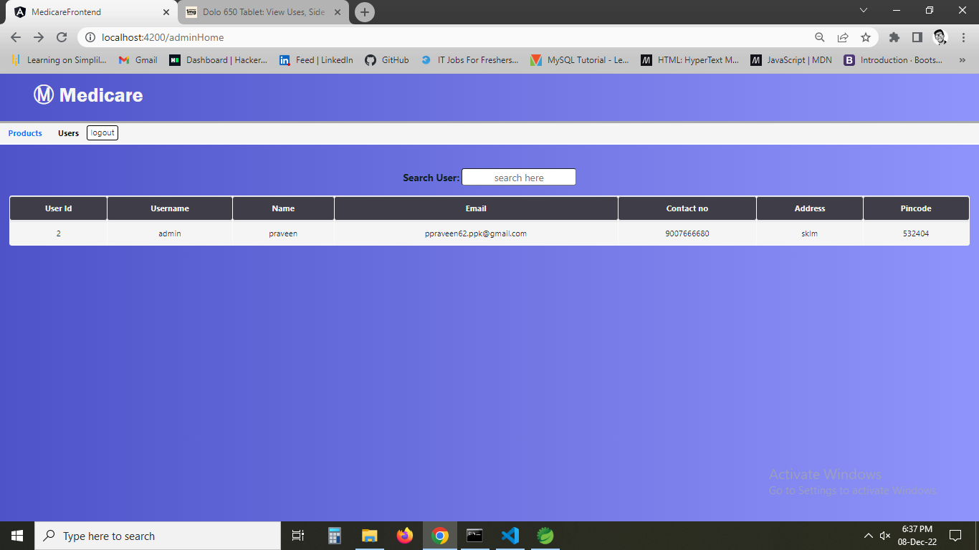

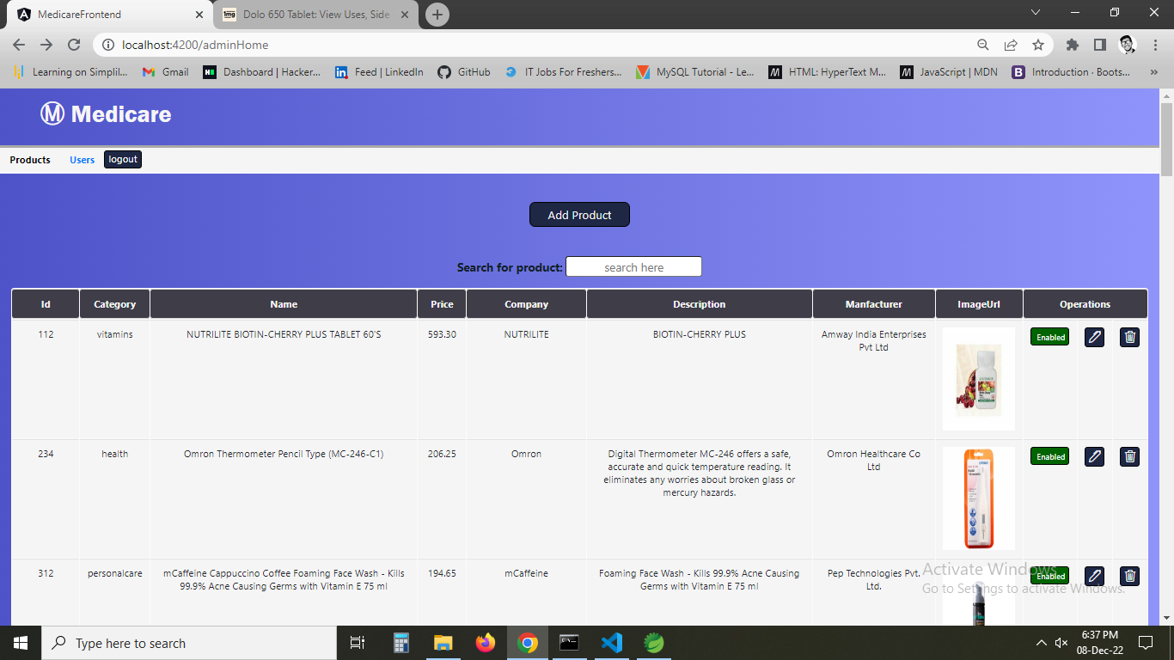

1. **now clicking create account.**

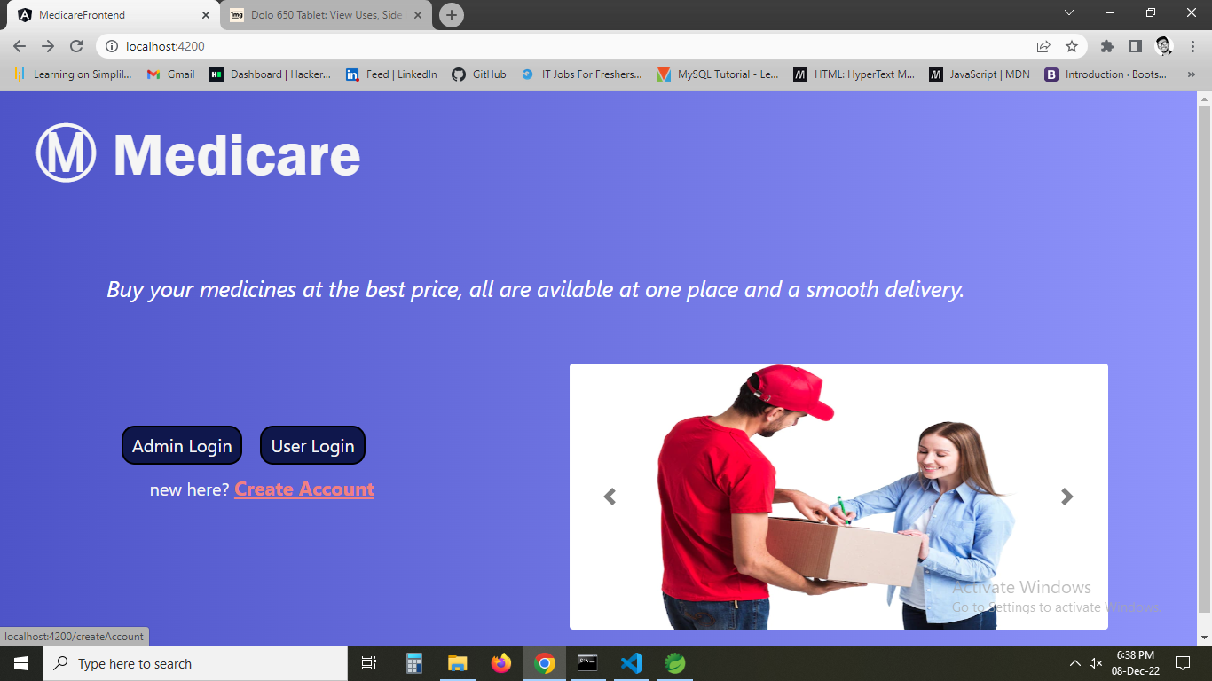

1. **the form to create account is dispalayed.**

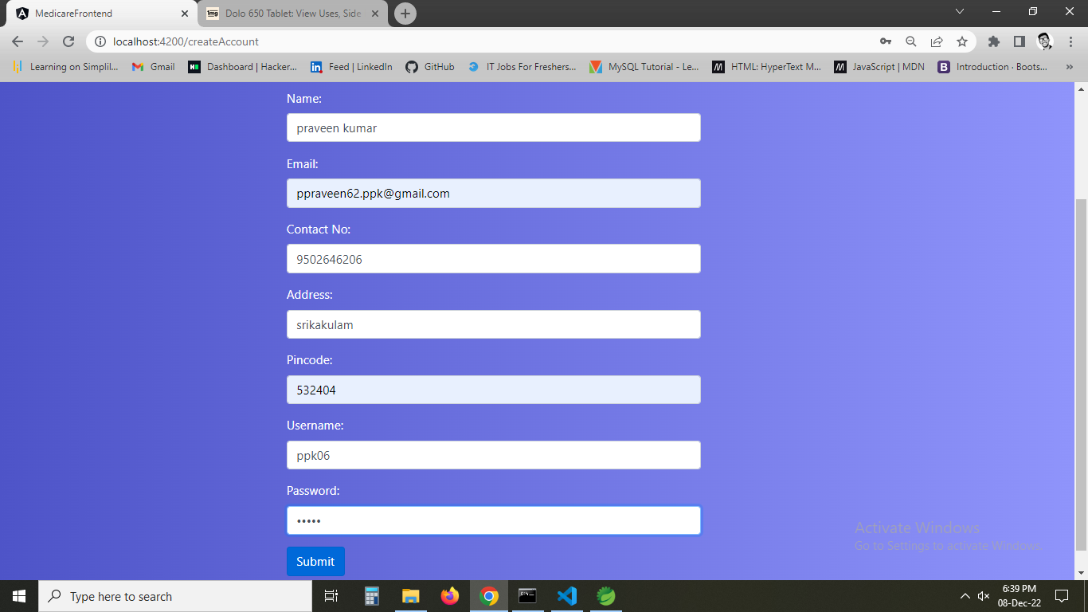

1. **now using userlogin.**

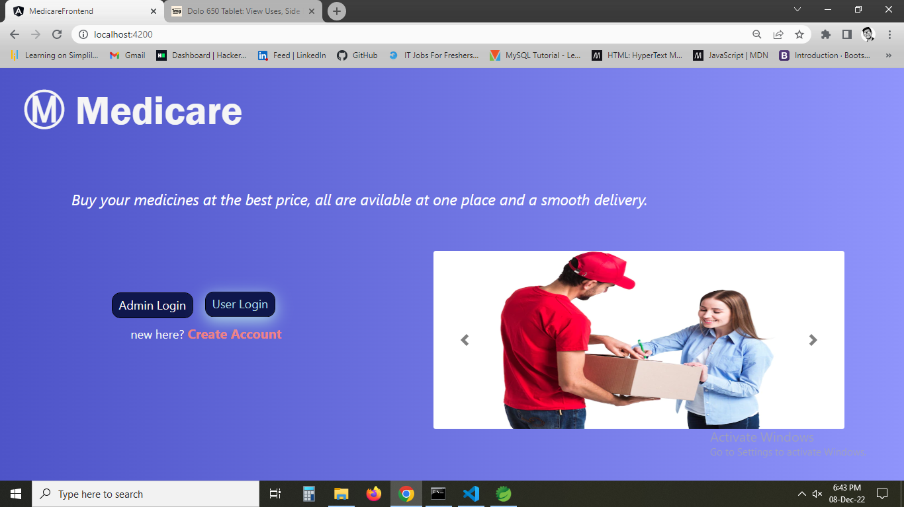

1. **Giving data**

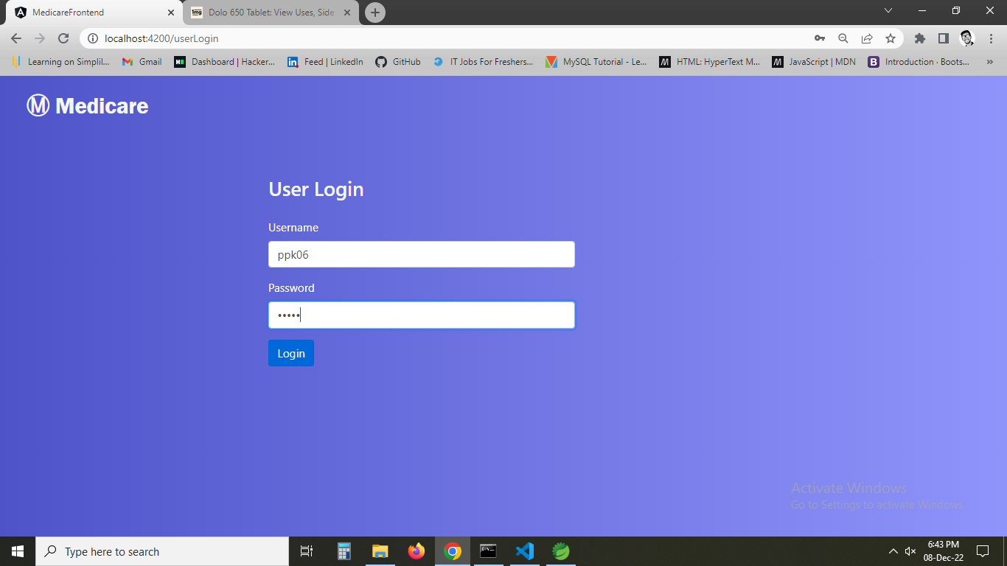

1. **Home page with username is displayed.**

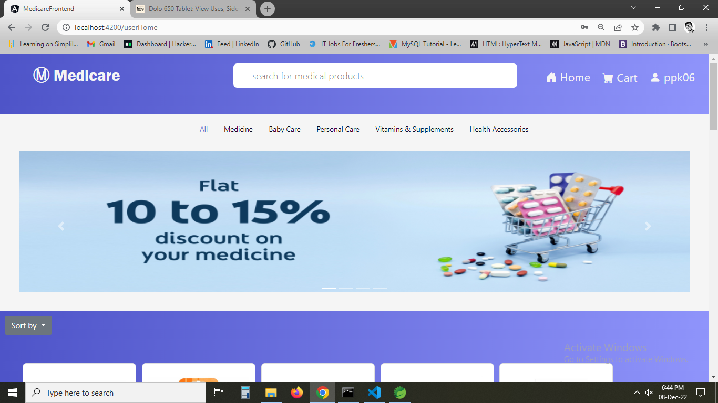

1. **Checking my cart showing no items**

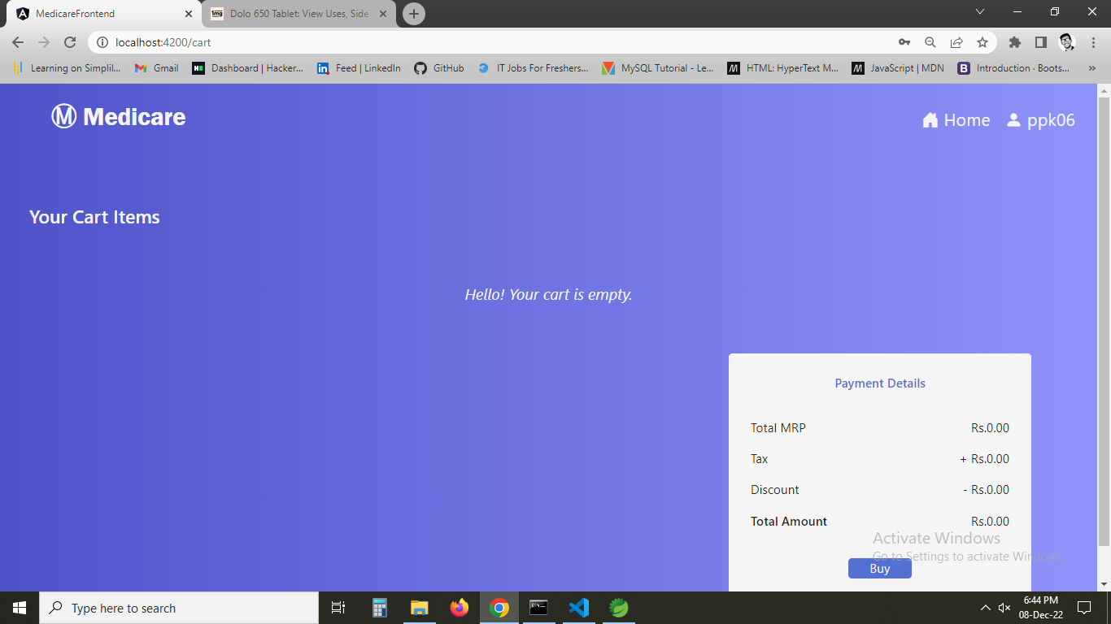

1. **Now trying to add items to cart it is showing successfully added to cart.**

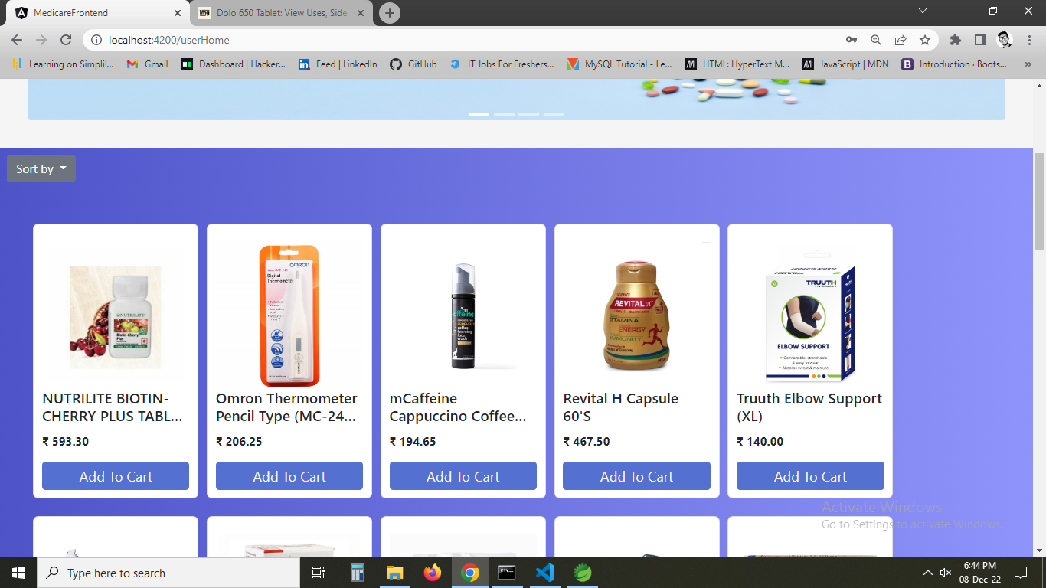

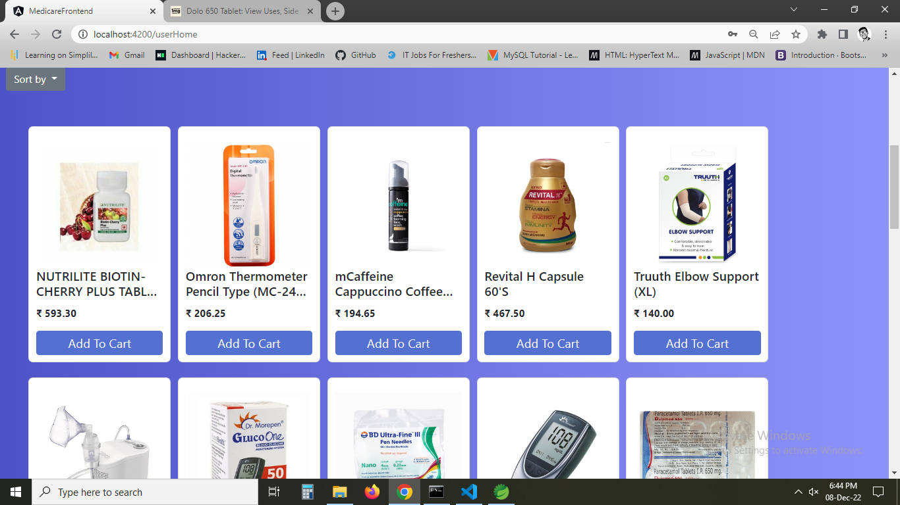

1. **All the added items are added to cart and payment details are shown.**

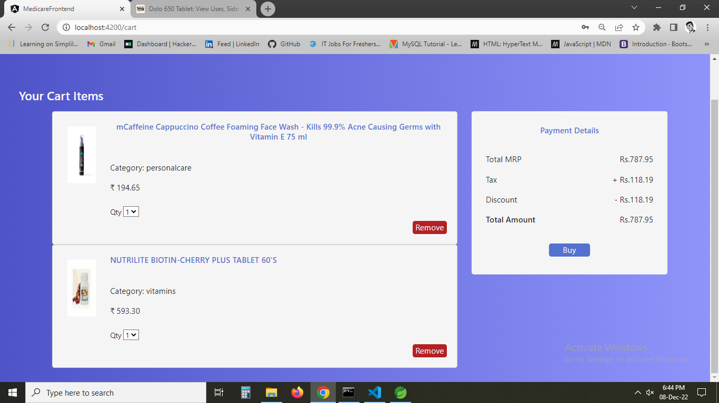

1. **Now removing item from the cart and the price is also updated.**

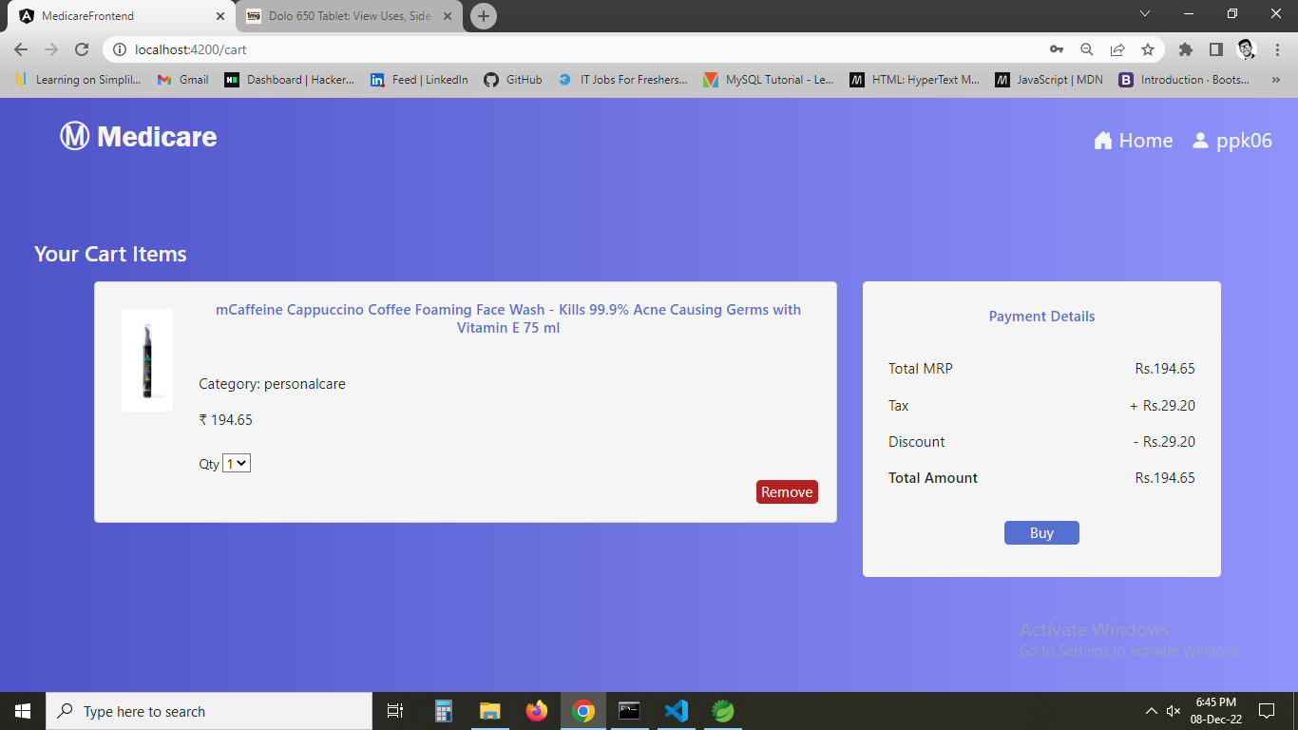

1. **Now on clicking Buy. Order summary is shown and card details are asked for further .**

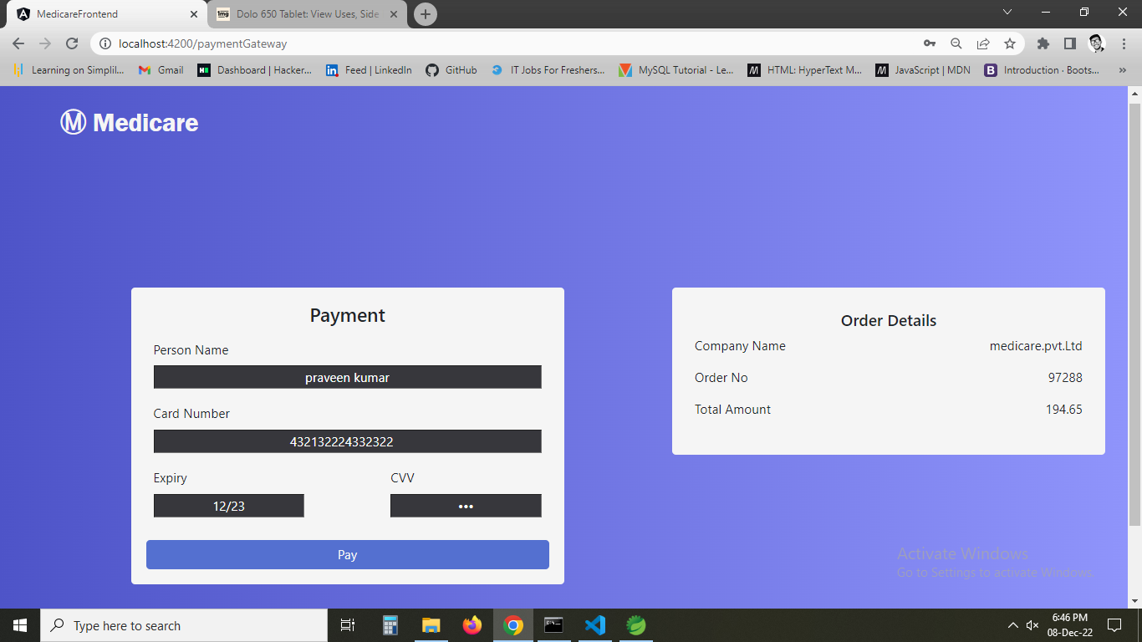

1. **On payment Order confirmation is shown with order no.**

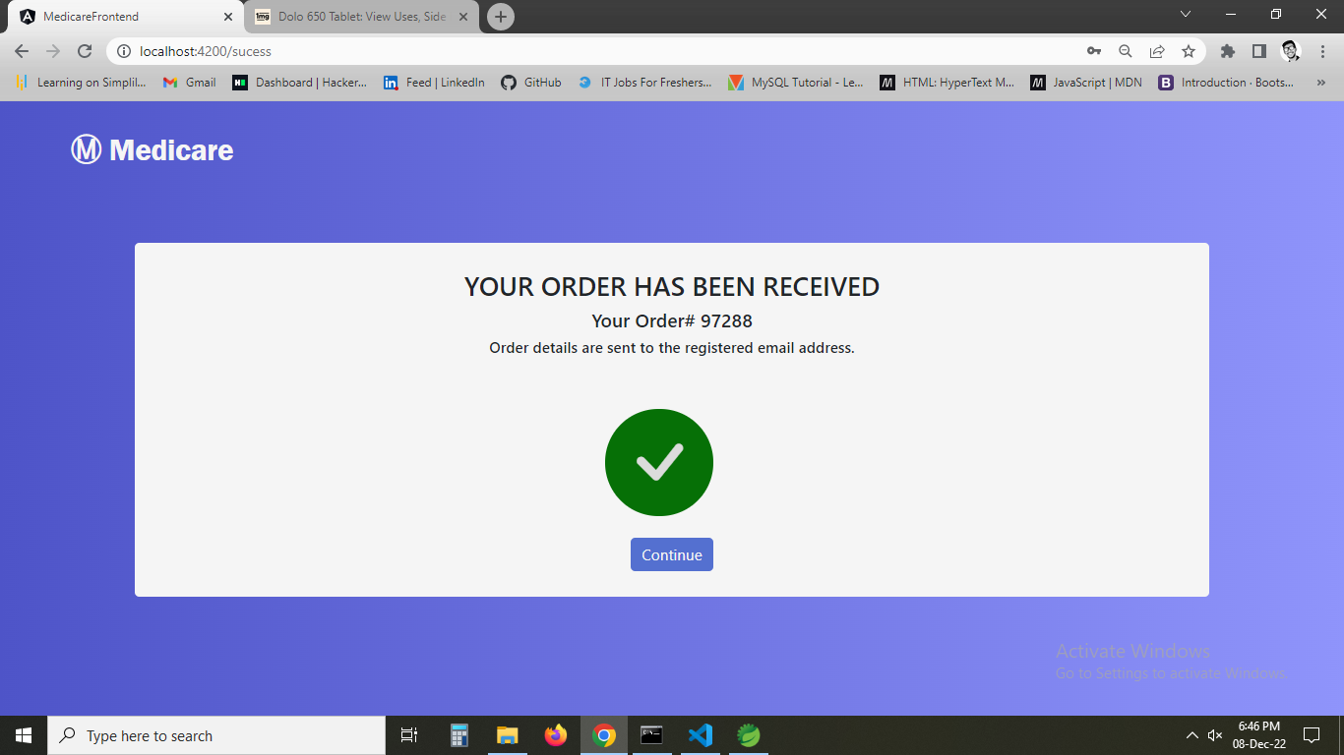

1. **Now going back to home page and checking orders**

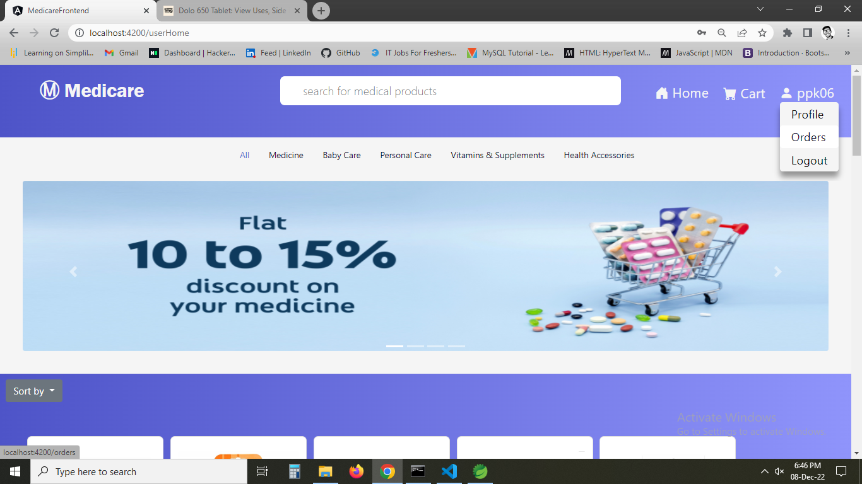

1. **Showing details of previous orders.**

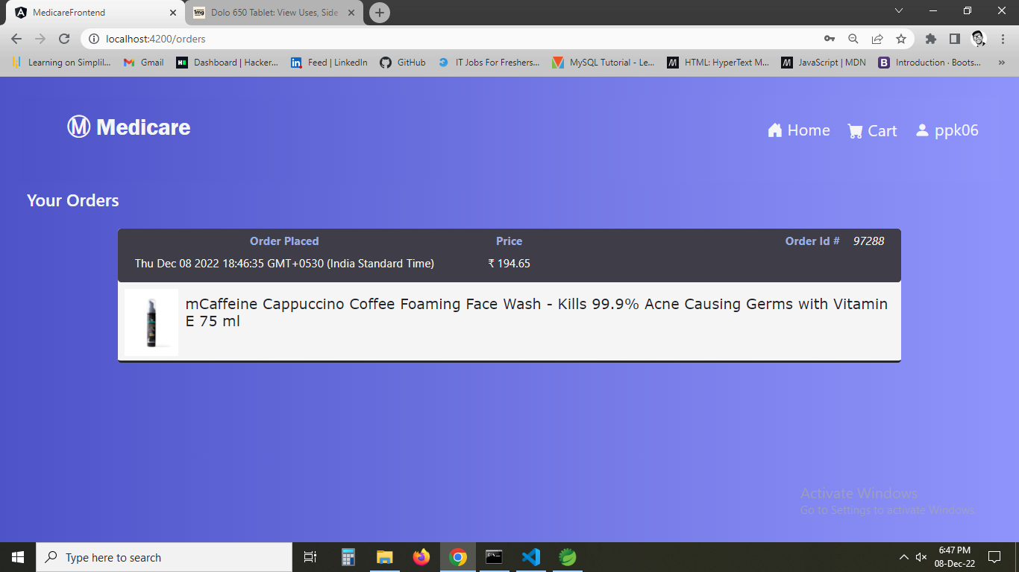

1. **Now again checking cart**

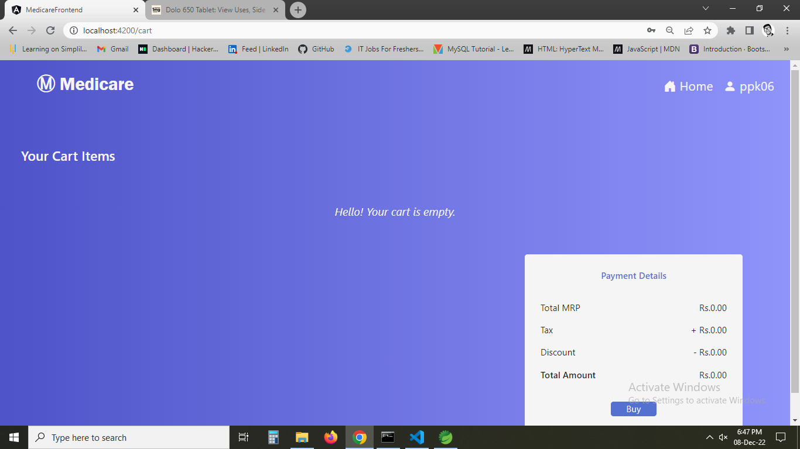

1. **Checking profile**

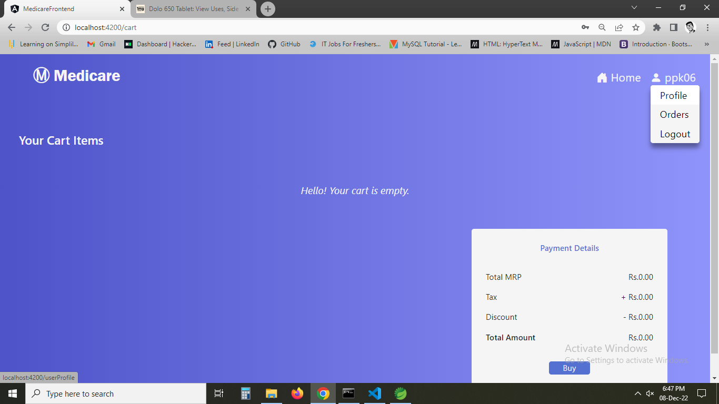

1. **Now profile data is shown and we can update profile here**

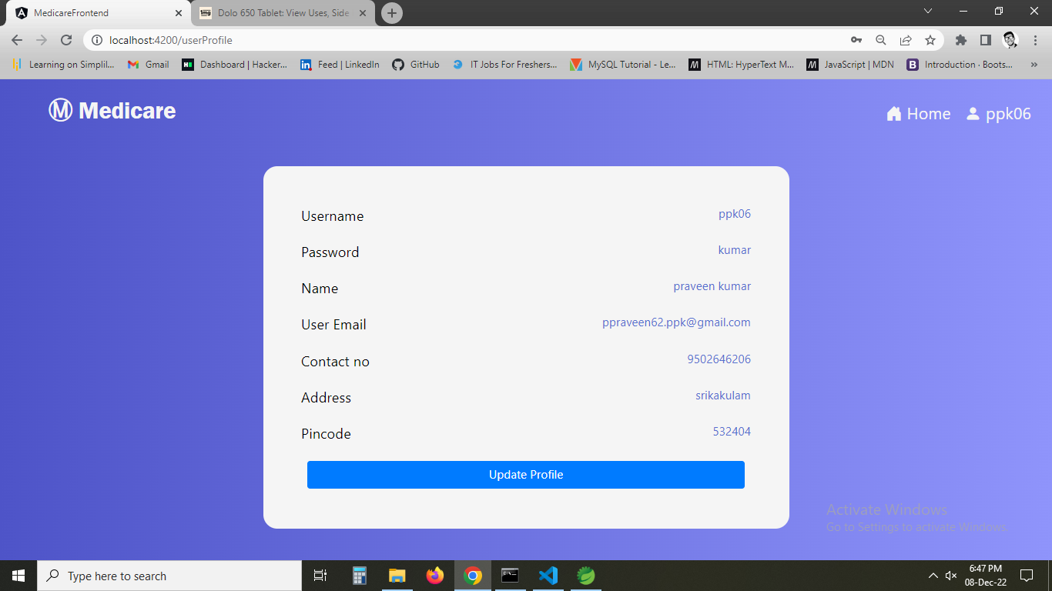

1. **On clicking particular product, product data are shown.**

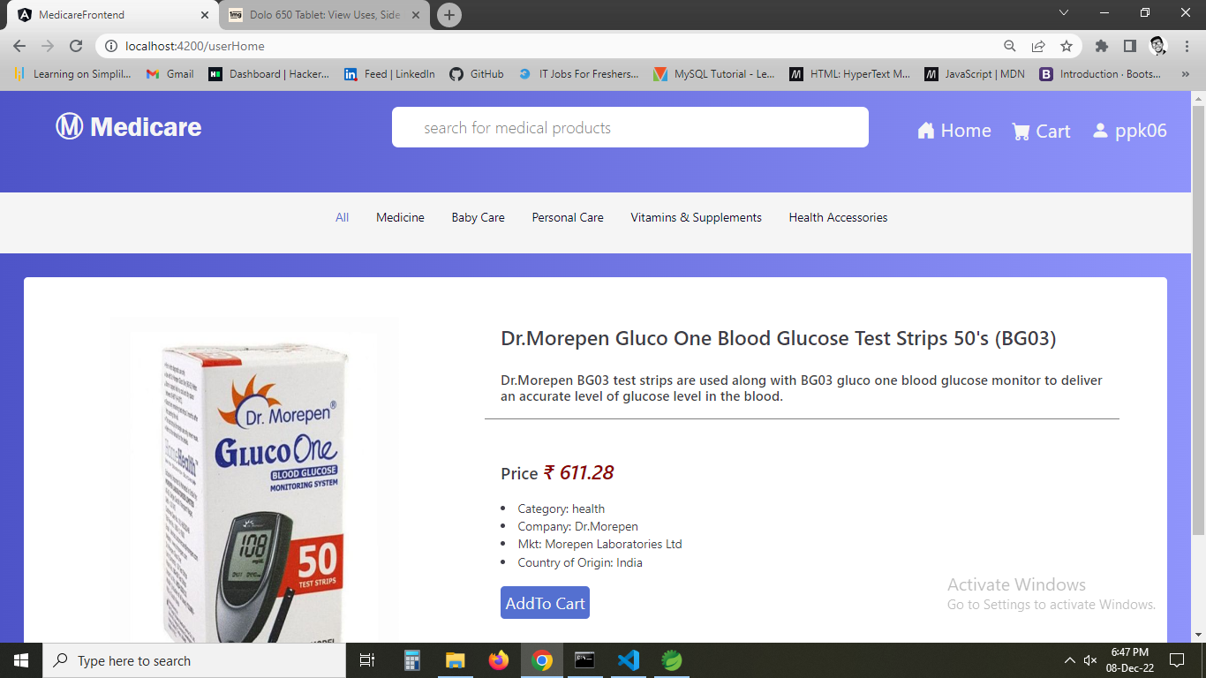

1. **Updating in github.**

